**SOLUTION DESIGN DOCUMENT**

**ECOM-Event Dashboard**

Version v1.5

Revision History

|  |  |  |  |
| --- | --- | --- | --- |
| Date | Revision | Author | Description |
| 18-07-2023 | V1.0 | Ashish Reddy and Almas Gajendragad | SDD |
| 06-12-2023 | V1.1 | Ashish Reddy and Almas Gajendragad | SDD |
| 03-01-2024 | V1.2 | Ashish Reddy and Almas Gajendragad | SDD |
| 12-01-2024 | V1.3 | Ashish Reddy and Almas Gajendragad | SDD |
| 14-05-2024 | V1.4 | Ashish Reddy and Almas Gajendragad | SDD |
| 07-06-2024 | V1.5 | Rajat Dhengre and Almas Gajendragad | SDD |

Contents

Revision History 1

Distribution 3

Introduction 4

Overview 4

Scope 4

Contacts 5

Quick Facts 5

Idea Assessment 5

Project 6

Architecture 7

Overview 7

Diagrams 7

Component 1 – On Premises Data Gateway 9

Component 2 – Power BI 11

Component 3 – Service Account Usage 12

Data 12

Inputs 14

Outputs 14

Storage and Preservation 14

Type 14

Volume 14

Regulatory Requirements 14

Security 15

Risks and Mitigation 15

Solution Metrics 16

License Estimation 16

Triggers 16

Business 16

Technical 16

# Distribution

The information has restricted distribution and viewing within Chanel.

Document Version Control

|  |  |  |  |
| --- | --- | --- | --- |
| Date Issued | Version | Description | Author |
| 17/07/2023 | V1.0 | SDD | Ashish Reddy/ Almas Gajendragad |
| 06/12/2023 | V1.1 | SDD | Ashish Reddy/ Almas Gajendragad |
| 03/01/2024 | V1.2 | SDD | Ashish Reddy/ Almas Gajendragad |
| 12/01/2024 | V1.3 | SDD | Ashish Reddy/ Almas Gajendragad |
| 15/05/2024 | V1.4 | SDD | Ashish Reddy/ Almas Gajendragad |
| 07/06/2024 | V1.5 | SDD | Rajat Dhengre/ Almas Gajendragad |

|  |  |  |
| --- | --- | --- |
| Name | Department | Responsibility |
| Brahim Boumrar | Finance Asia Pacific | Sign off |
| Rakesh Prabhu | Business System Analyst (Retail) | Review |

Document Sign-off Requirements (NA)

The following table contains the people required to sign-off and/or review this document and those that require the document for information only.

# Introduction

## Overview

AX team is responsible for capturing the data coming from different sources all over the APAC Region. The team is facing difficulty tracking “Sales orders” through all stages from “Sales order” creation to invoice.

The Problem is that the team is facing difficulties tracking the sales order due to large database which time consuming. Hence this led to an idea of creating the dashboard so that data monitoring and tracking of “Sales orders” would be easy to understand.

## Scope

**In Scope:**

* Region: APAC
* Markets: No Business Impacts, Data from mentioned market are used for the dashboard **Australia, Hongkong, Malaysia, Singapore, Thailand, Taiwan**
* Staff: IT Unit
* Data Files:
  + AX.CnlRetailTransactionTable
  + CnlRetailTransactionTable
  + RetailtransactionorderStatus
  + ax.RetailtransactionorderStatus
  + OneChanel.CNLOCAcknowledgmentlog
  + CNLStockvalidation
  + ax.CnlStockvalidation
  + OneChanel.CNLOCPickeventlog
  + ILSGatewayQueue (Direction = Outbound and BatchStatus = Ended)
  + ILSGatewayQueue (Direction = Inbound and BatchStatus = Ended)
  + CustInvoiceJourTable
  + AX.CustInvoiceJourTable
  + Onechanel.CNLOCInvoiceEventLog

## Contacts

|  |  |  |
| --- | --- | --- |
| Key Contacts | Email ID | Role |
| Rakesh Prabhu | rakesh.prabhu@chanel.com | Senior Business Consultant |
| Roobesh Karuvanandiyil | roobesh.karuvanandiyil@chanel.com | Senior Business Consultant |
| Tarren Gomes | tarren.gomes@chanel.com | Senior Technical Consultant |
| Dilip Thankappan | dilip.thankappan@chanel.com | RPA Solution Lead |
| Rajat Dhengre | rajat-r.d@chanel.com | Power BI Developer |
| Almas Gajendragad | [almas.s-gajendragad@chanel.com](mailto:almas.s-gajendragad@chanel.com) | Power BI Developer |

# Quick Facts

## Idea Assessment

|  |  |
| --- | --- |
| Topic | Value |
| Business Unit  *(1. Fashion, 2. Fragrance and Beauty, 3. WFJ)* | 1,2,3 |
| Use Case  *(Automation, Mobile/tablet App, Web Portal, Workflow, Chatbot, IDP, ML/AI, Others)* | *Dashboard* |
| Impact on Business  *(Business Critical, Not Business Critical)* | Not Business Critical |
| Users  *(Individual or Small Team, Large Team or Service, Department or Region)* | Individual or Small Team |
| Power Platform Features  *(Power Automate, Power Apps, Power Virtual Agents, Power BI, Power Automate Desktop, AI Builder)* | Power BI |
| Power Platform Connectors  *(List of Power Platform Connectors)* | On-premises Data-Gateway |
| System Interactions | SQL |

## Project

|  |  |
| --- | --- |
| Topic | Value |
| Project Type  *(GYRB)* | G |
| Environments  *(GYRB)* | G |
| Licensing | Microsoft 365 E5 |
| Track  *(Business Project, Citizen IT)* | Business Project |
| External Partner* | NA |

*\* Business Projects only*

# Architecture

## Overview

The data from SQL Servers “HKDATAXSQLP8” and “HKDATAXSQLP4” will be connected to Power BI and the live data will be coming into Power BI.

The following steps will be performed in this process.

**Power BI:** Power BI will be used to create the ECOM Event Tracking Dashboard. Which will provide the information/ Status of “Sales order", "Fluent ID” and “Hybris Order ID”.

## Diagrams

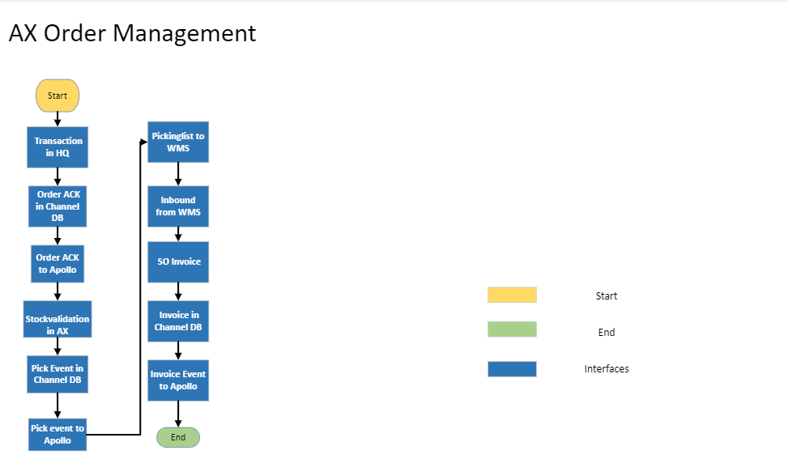

**Diagram 1.0**: All stages a sales order goes through.

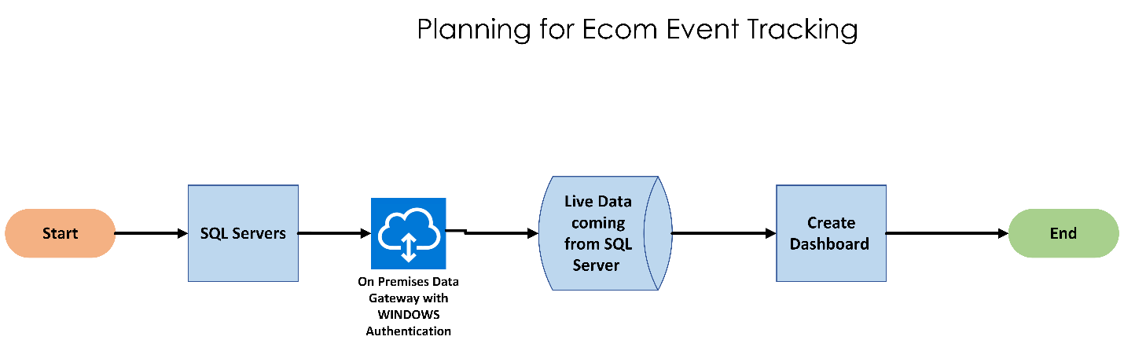

**Diagram 1.1**: Dashboard Planning Diagram

***Refer this below file to view the ER Diagram in more detail:***

[SDD Diagrams](https://lpl-my.sharepoint.com/:u:/r/personal/rajat-r_d_chanel_com/Documents/SDD%20Diagrams.vsdx?d=w2a79614a277646c791427bd80bf4afa8&csf=1&web=1&e=4bYycL)

**Diagram 1.2**: ER (Entity Relationship) Diagram (Click on the icon to view the diagram)

|  |  |  |
| --- | --- | --- |
| **Reference tables in Power BI** | **Table from server** | **Server** |
| ALL_MARKET_AX.CnlRetailTransactionTable | AX.CnlRetailTransactionTable **X 6** | HKDATAXSQLP4 |
| CnlRetailTransactionTable | CnlRetailTransactionTable | HKDATAXSQLP8 |
| ALL_MARKET_AX.RetailtransactionorderStatus | ax.RetailtransactionorderStatus **X 6** | HKDATAXSQLP4 |
| ALL_MARKET_OneChanel.CNLOCAcknowledgmentlog | OneChanel.CNLOCAcknowledgmentlog **X 6** | HKDATAXSQLP4 |
| CNLStockvalidation | CNLStockvalidation | HKDATAXSQLP8 |
| ALL_MARKET_ ax.CnlStockvalidation | ax.CnlStockvalidation **X 6** | HKDATAXSQLP4 |
| ALL_MARKET_ OneChanel.CNLOCPickeventlog | OneChanel.CNLOCPickeventlog **X 6** | HKDATAXSQLP4 |
| ILSGatewayQueue | ILSGatewayQueue | HKDATAXSQLP8 |
| ALL_MARKET_ AX.CustInvoiceJourTable | AX.CustInvoiceJourTableX6 | HKDATAXSQLP4 |
| ALL_MARKET_ Onechanel.CNLOCInvoiceEventLog | Onechanel.CNLOCInvoiceEventLog **X 6** | HKDATAXSQLP4 |
| CustInvoiceJourTable | CustInvoiceJourTable | HKDATAXSQLP8 |

Note: In the table “X 6” means that the corresponding table in ‘Reference tables in Power BI’ is a combination of 6 tables of the ‘Table from server’. The 6 is the number of markets (AUS, SGP, HKG, MYS, THA, TWN), and the combination of tables from all markets have been put under the name mentioned in Reference table column

**Components**

## Component 1 – On Premises Data Gateway

1. Install On premises data gateway
   * 1. Login to licensed Power Apps and click on Connections and then click on new connect after that select SQL connection.

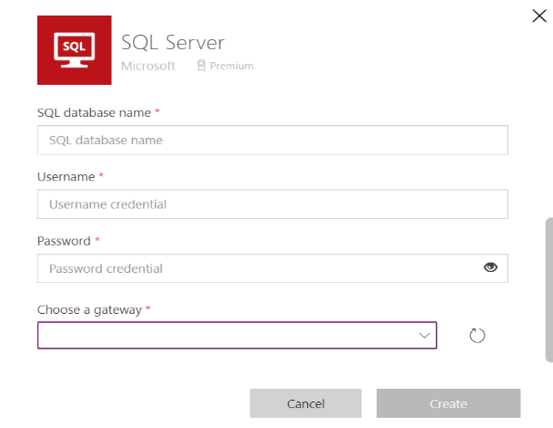

* + 1. Click on install gateway option.

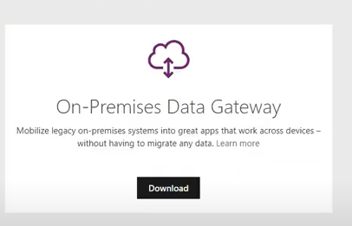

* + 1. During the installation setup provide Power Platform credentials

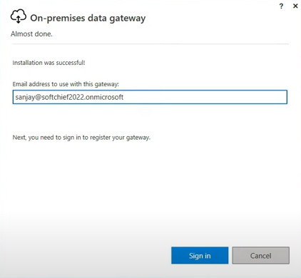

* + 1. After sign in fill-up the other fields like. New name for the gateway and set a recovery key

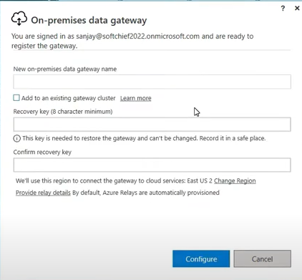

* + 1. After the configuration, the last tab would look like this, with status as “Ready: for Power Apps, Power automate and Power BI.

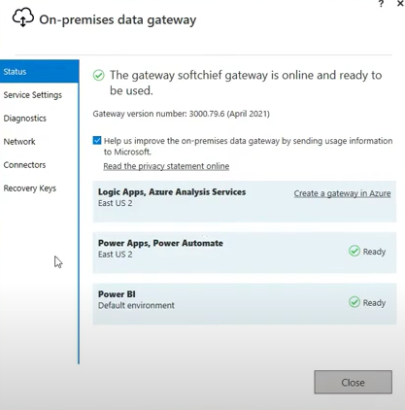

* + 1. Next Step would be going back to Power Apps and again click on new connection. Choose Windows Authentication for Authentication type. Once the gateway is installed it will be visible at the gateway selection drop down.

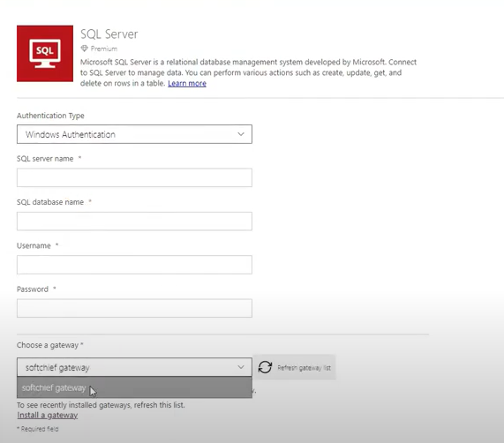

## Component 2 – Power BI

* A connection will be created between SQL and Power BI through on premises data gateway.
* After the connection is setup, select the required tables.
* Once the tables are fetched in Power BI, transform the data.
* This data will be used to track “Sales Orders”.
* We then start creating the dashboard with all the required entities.

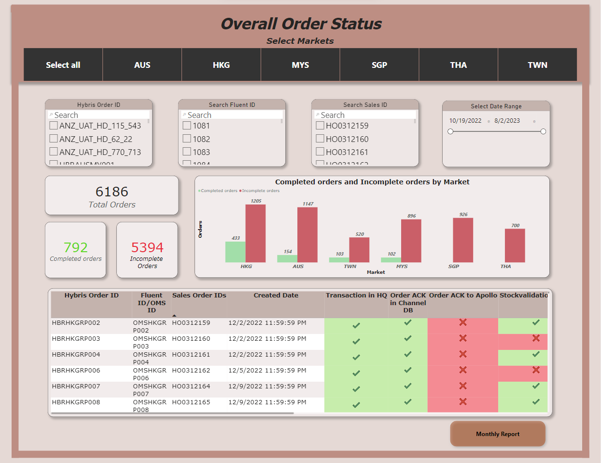

## Component 3 – Service Account Usage

**Description**

Service Account

* For the connection of Gateway and mentioned server HKDATAXSQLP8 and HKDATAXSQLP4, there will be a new service account.

**Service Account Username: sa-cgapac-automation**

# Data

1. **Master Tables are:**

**ALL_MARKET_AX.CnlRetailTransactionTable – Master Table:** Column needed in Master Table are:

* Fluent Id
* Sales Order ID
* Data Area ID
* Created Date
* Hybris Order ID
* Market

1. **Date Tables are:**
2. **CnlRetailTransactionTable:** Column required in the table are:

* **Fluent ID –** Primary Key

1. **RetailtransactionorderStatus :** Column required in table are:

* **Fluent ID** – Primary Key
* Sales Order ID

1. **ALL_MARKET_AX.RetailtransactionorderStatus:** Column required in table are:

* **Fluent ID** – Primary Key

1. **ALL_MARKET_OneChanel.CNLOCAcknowledgmentlog:** Column required in table are:

* **Sales Order ID –** Primary Key
* Data Area ID

1. **CNLStockvalidation:** Column required in table are:

* **Sales Order ID** – Primary Key
* Data Area ID

1. **ALL_MARKET_ ax.CnlStockvalidation:** Column required in table are:

* **Sales Order ID** – Primary Key
* Data Area ID

1. **ALL_MARKET_ OneChanel.CNLOCPickeventlog:** Column required in table are:

* **Sales Order ID** – Primary Key

1. **ILSGatewayQueue:** Column required in table are:

* **Sales Order ID** – Primary Key
* XML Direction

1. **CustInvoiceJourTable:** Column required in table are:

* **Sales Order ID** – Primary Key
* Data Area ID

1. **ALL_MARKET_ AX.CustInvoiceJourTable:** Column required in table are:

* **Sales Order ID** – Primary Key
* Data Area ID

1. **ALL_MARKET_ Onechanel.CNLOCInvoiceEventLog:** Column required in table are:

* **Sales Order ID** – Primary Key

## Inputs

Data Transfer will happen from SQL server to Power BI through on-premises data gateway.

## Outputs

A Dashboard will be created using Power BI.

## Storage and Preservation

All data details will be stored within the Dataverse.

## Type

- Confidential

## Volume

## Regulatory Requirements

NA

# Security

## Risks and Mitigation

<Brief overview on how the different stakeholders interact with the solution, what are the risks associated and the mitigation actions for those risks>

No Risk, Because the dashboard will be used to track only the status of Sales Orders.

# Solution Metrics

## License Estimation

SQL Connector in Power Apps

## Triggers

* Power BI: A scheduled refresh will happen to get the data from SQL server.

## Business

<List all know business exceptions, per task, that are expected for the solution. Each exception should include details such as the task, exception description, affected applications and manual actions required to solve issue either by Business or Support teams>

## Technical

<List all know system exceptions, per task, that are expected for the solution. Each exception should include details such as the task, exception description, affected applications and manual actions required to solve issue or to alert the person/team that can solve the issue>

* On-Premises data gateway setup for SQL connection